**Group : TY-25**

**Batch: B-3**

**Requirement Elicitation Techniques**

**Car Rental System**

# **1) Stakeholder Analysis:**

Several different types of stakeholders can be noted when it comes to our software Car Rental System.

1. **The CEO and company board members**

These are the most **obvious** who have requested this software. We made note to critical details on what the **company** wants, how they want it, and how it should benefit both them and their clients. We plan to keep them in the know **24/7**, keeping them informed on what is being **planned** for their new software. This allows for the CEO and board members to be aware of what they are **getting** from their new software.

1. **The Managers**

Any local or district managers are also influenced by the software’s stability. How easy the software is for the employees in turn represents how well the manager is able to **guide** them through it.

1. **The employees**

The employees will also be affected by the use of the software, it is not only their obligation to learn the software, but for us to make it easily **learnable**. In this case there will be days dedicated to teaching the employees how to run the software for an easy navigational experience. Their input will also go into the **testing** process, making sure everything is to their liking and runs efficiently and effectively.

1. **Customers**

Customers are also vital stakeholders, and with a mobile/web car rental service, one can find the convenience of obtaining a car with circumstances ranging from their current vehicle breaking down to needing a means of transport during vacation. This puts an extreme time saving benefit of the customer having to search around to even find a car rental building. With the car rental service, they will help you locate the store as well as even take the car to you, if the customer so chooses.

1. **Car Manufacturers and suppliers**

The car rental company could also have partnerships with some big car brands. Car companies can sell cars to car rental companies and another way that could also work for rental companies is that common people who want to make money by their cars can also provide cars to rental companies and earn money.

|  |  |
| --- | --- |
| **KEEP SATISFIED** **Customers** | **MANAGE CLOSELY** **Car Manufacturers and suppliers, The Managers** |
| **MONITOR** **The Employees** | **KEEP INFORMED** **The CEO and company board members** |

# **Requirements found from stakeholder analysis:**

1. **To combine business requirements with technical requirements on the software**
2. **To secure any transmissions of private information between the customer and the company**

# **2) Prototyping:**

* **User module & Booking System :**

User can -

* Register through Registration page
* Registered Users can login with valid email and password.
* Recover Forget password after Email Verification.
* Find car details and Book cars.
* View Car booking history
* Check Booking Status(admin can approve or disapprove)
* Update their Profile & Password.
* Add New Testimonials
* Logout

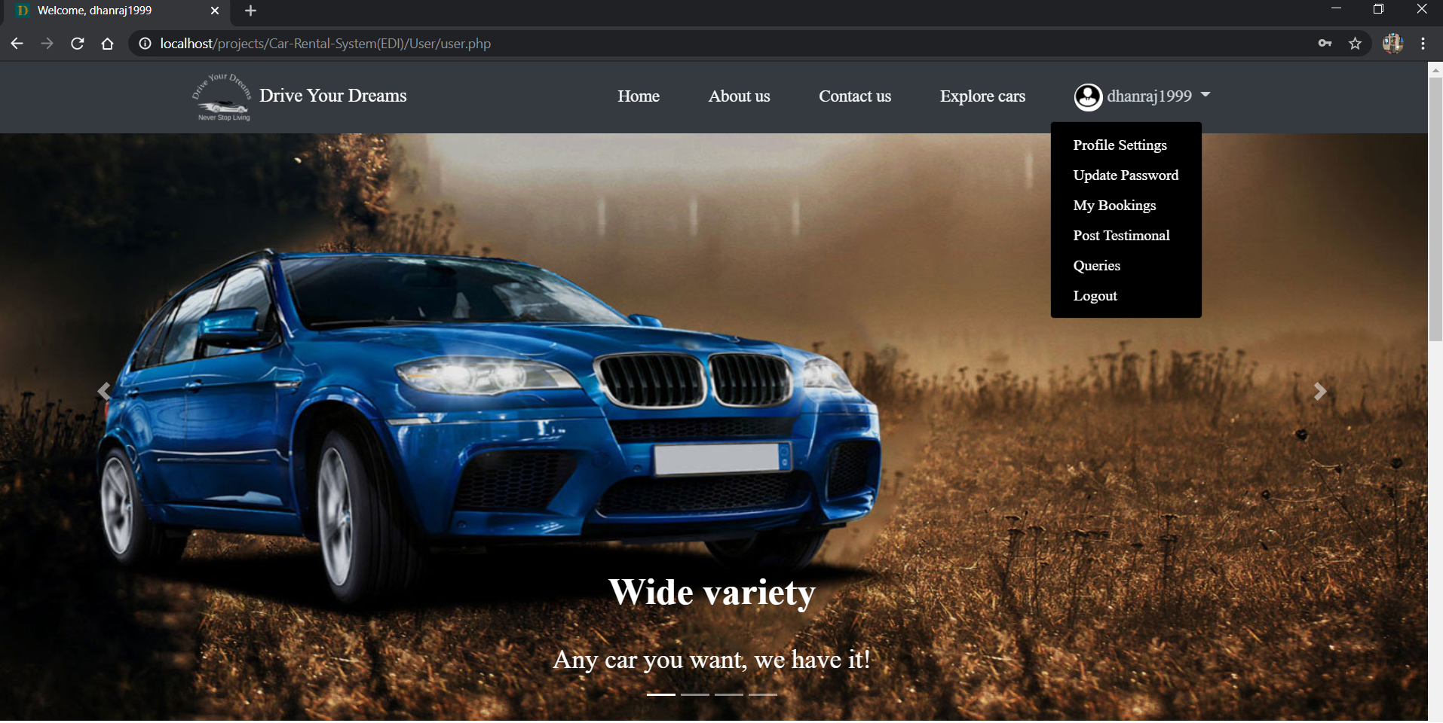

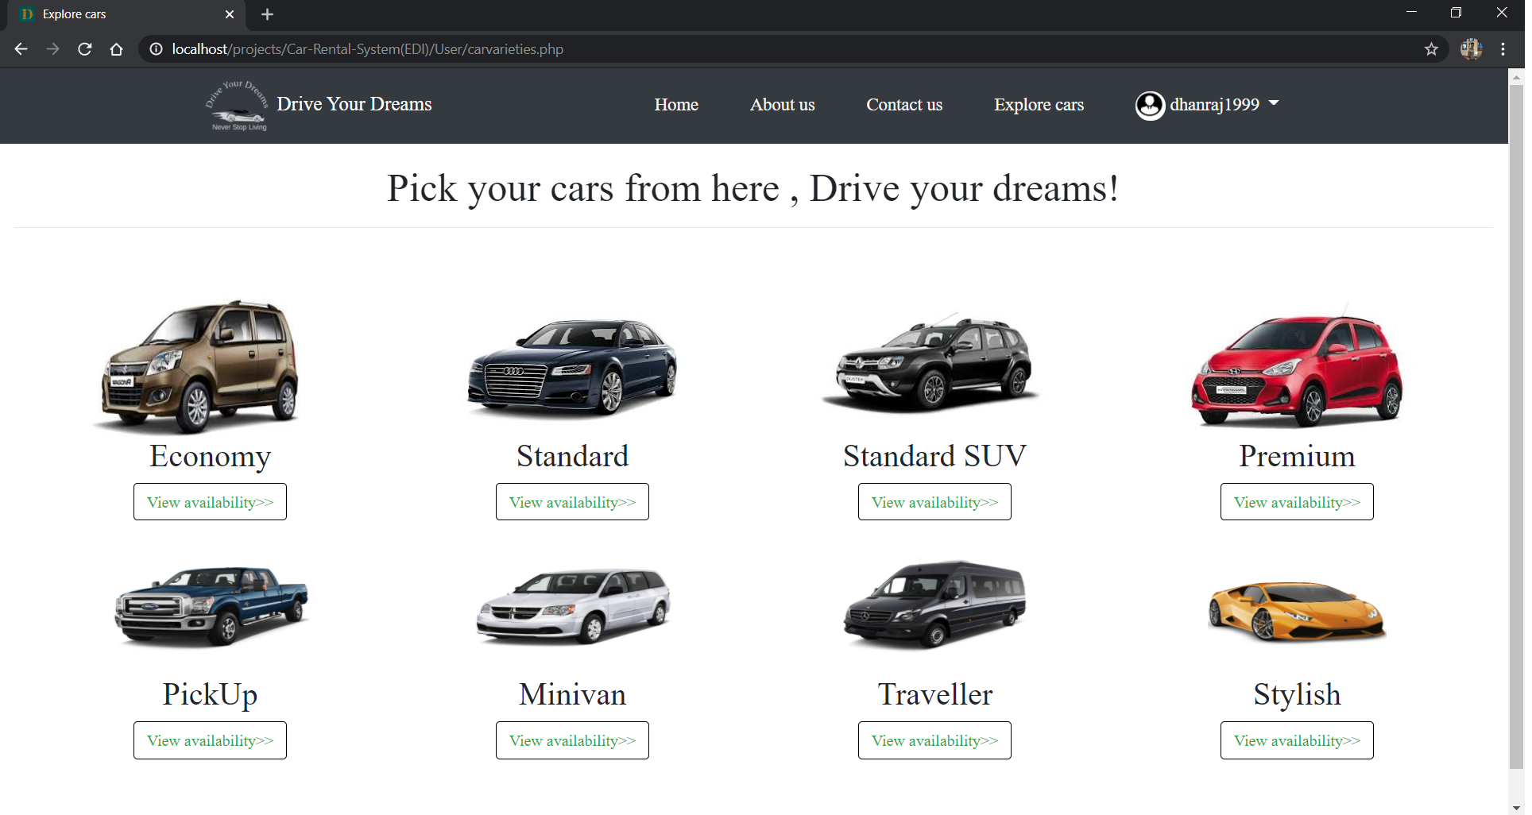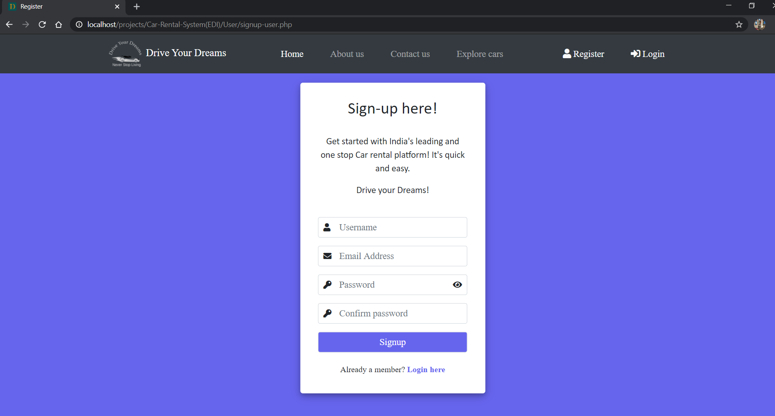

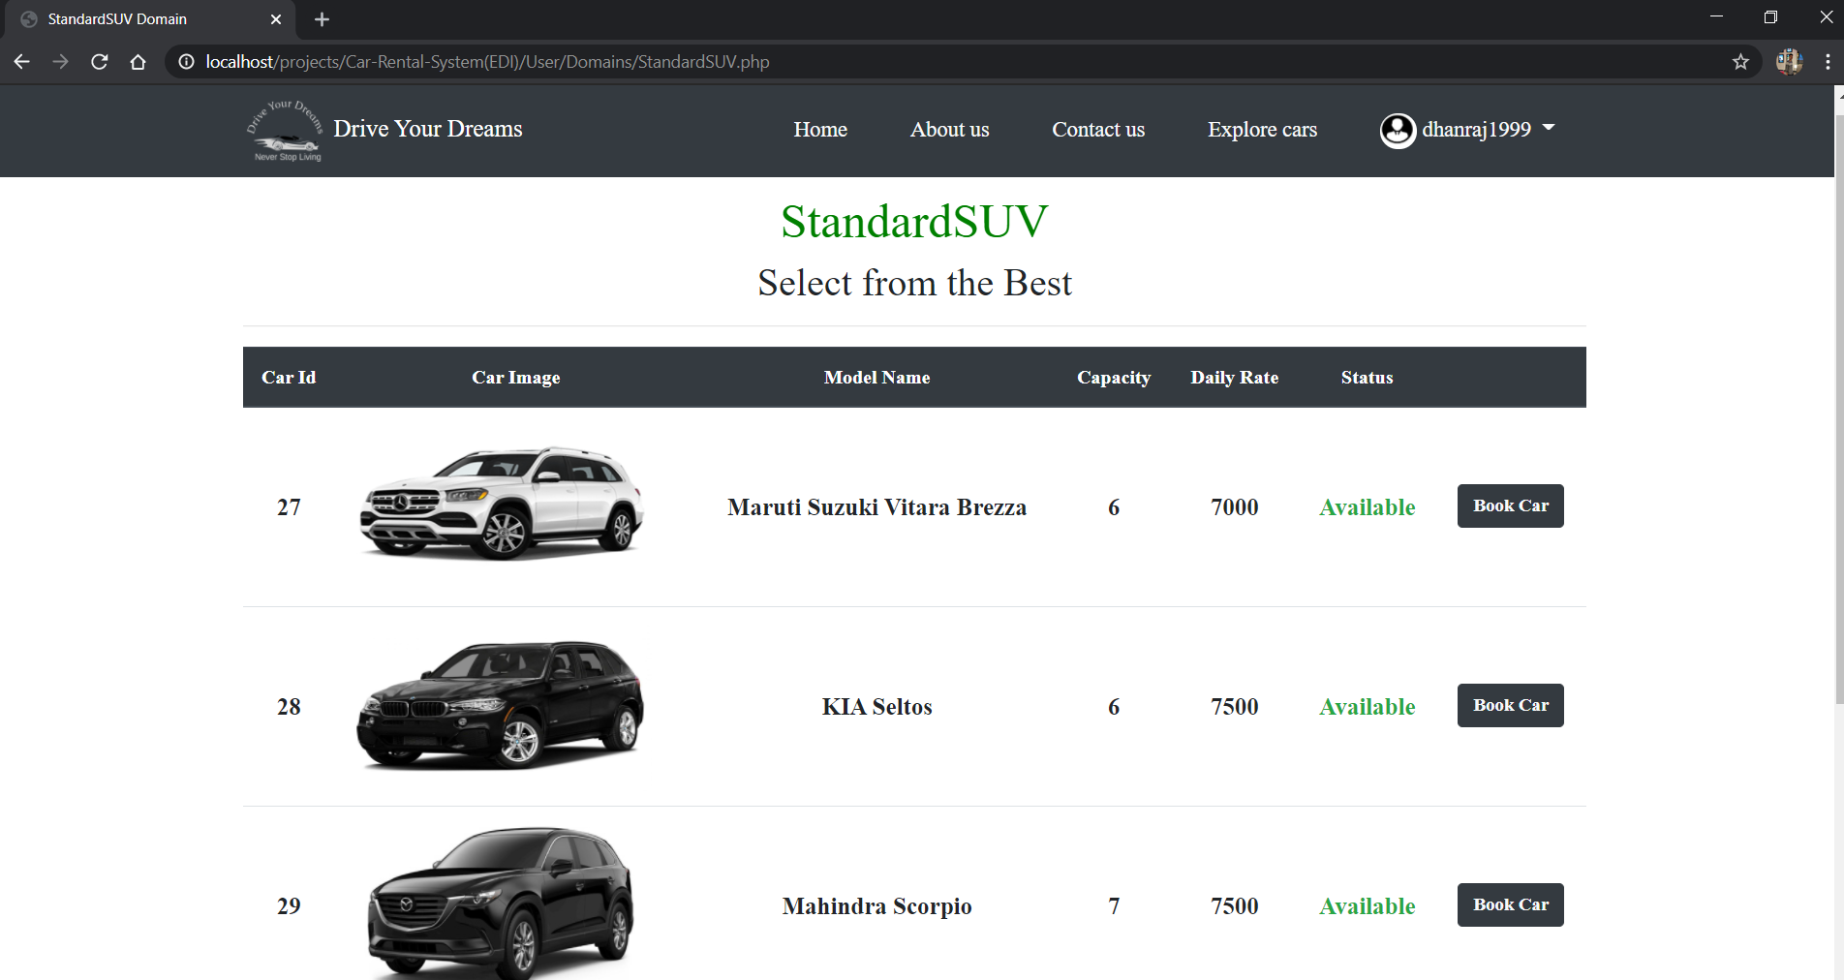

* **Admin Module**

Admin can -

* View Registered Users & details
* Admin can Manage & Add cars
* Manage bookings
* Manage testimonial
* Manage user-queries.

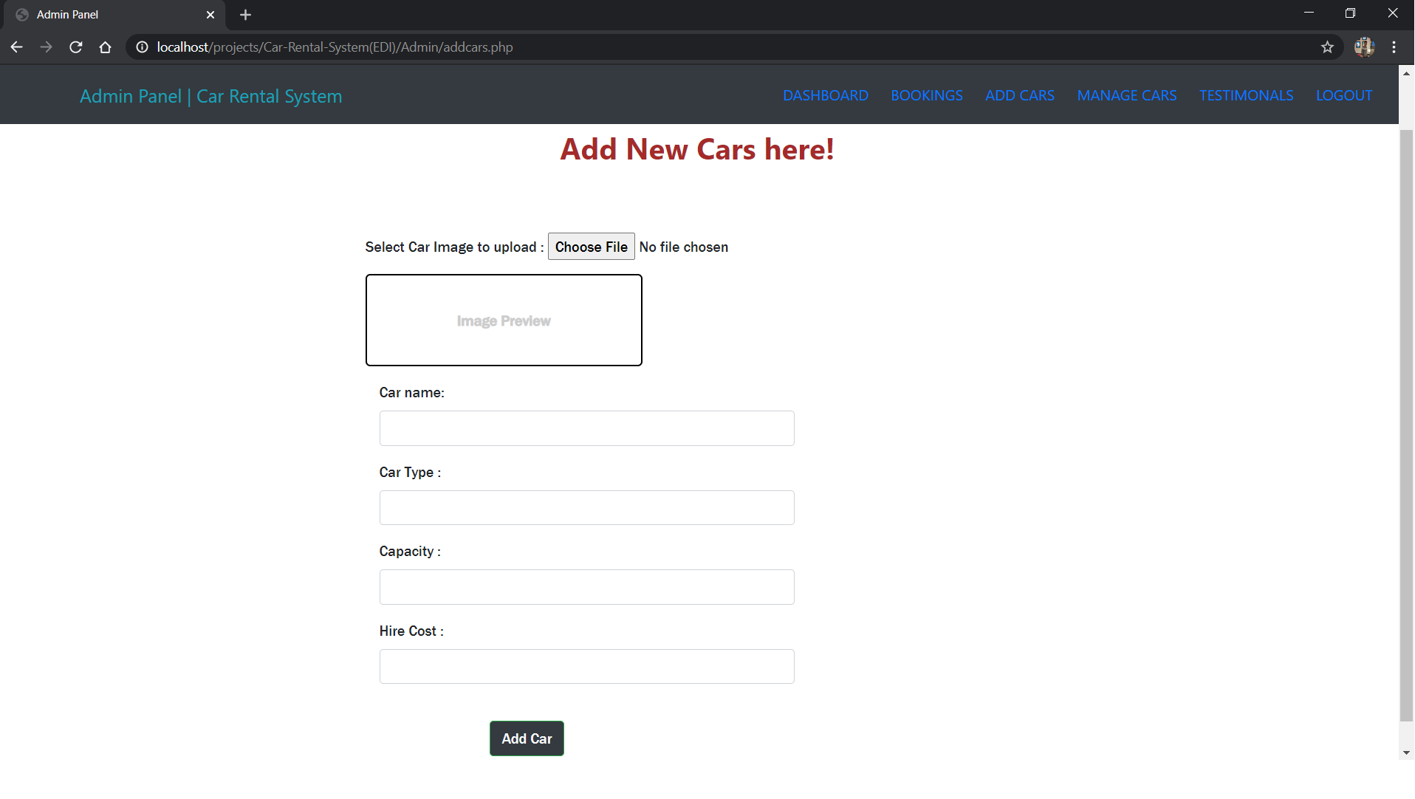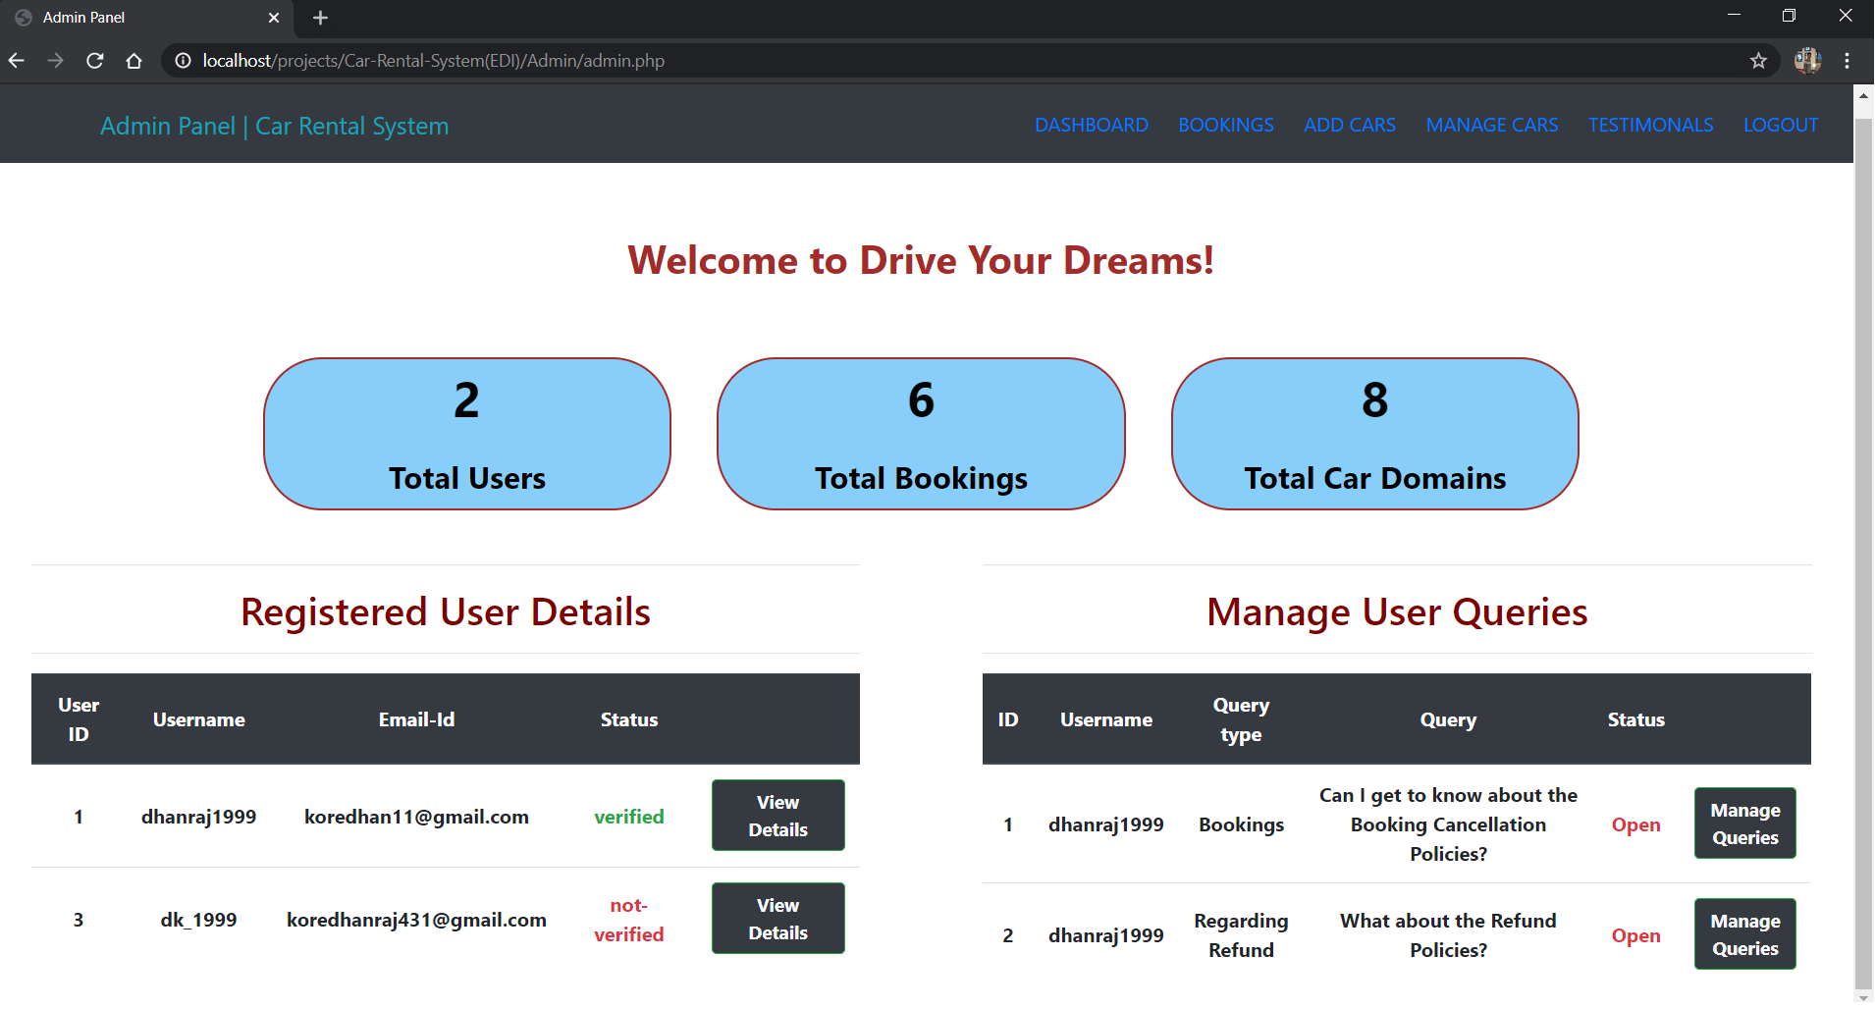

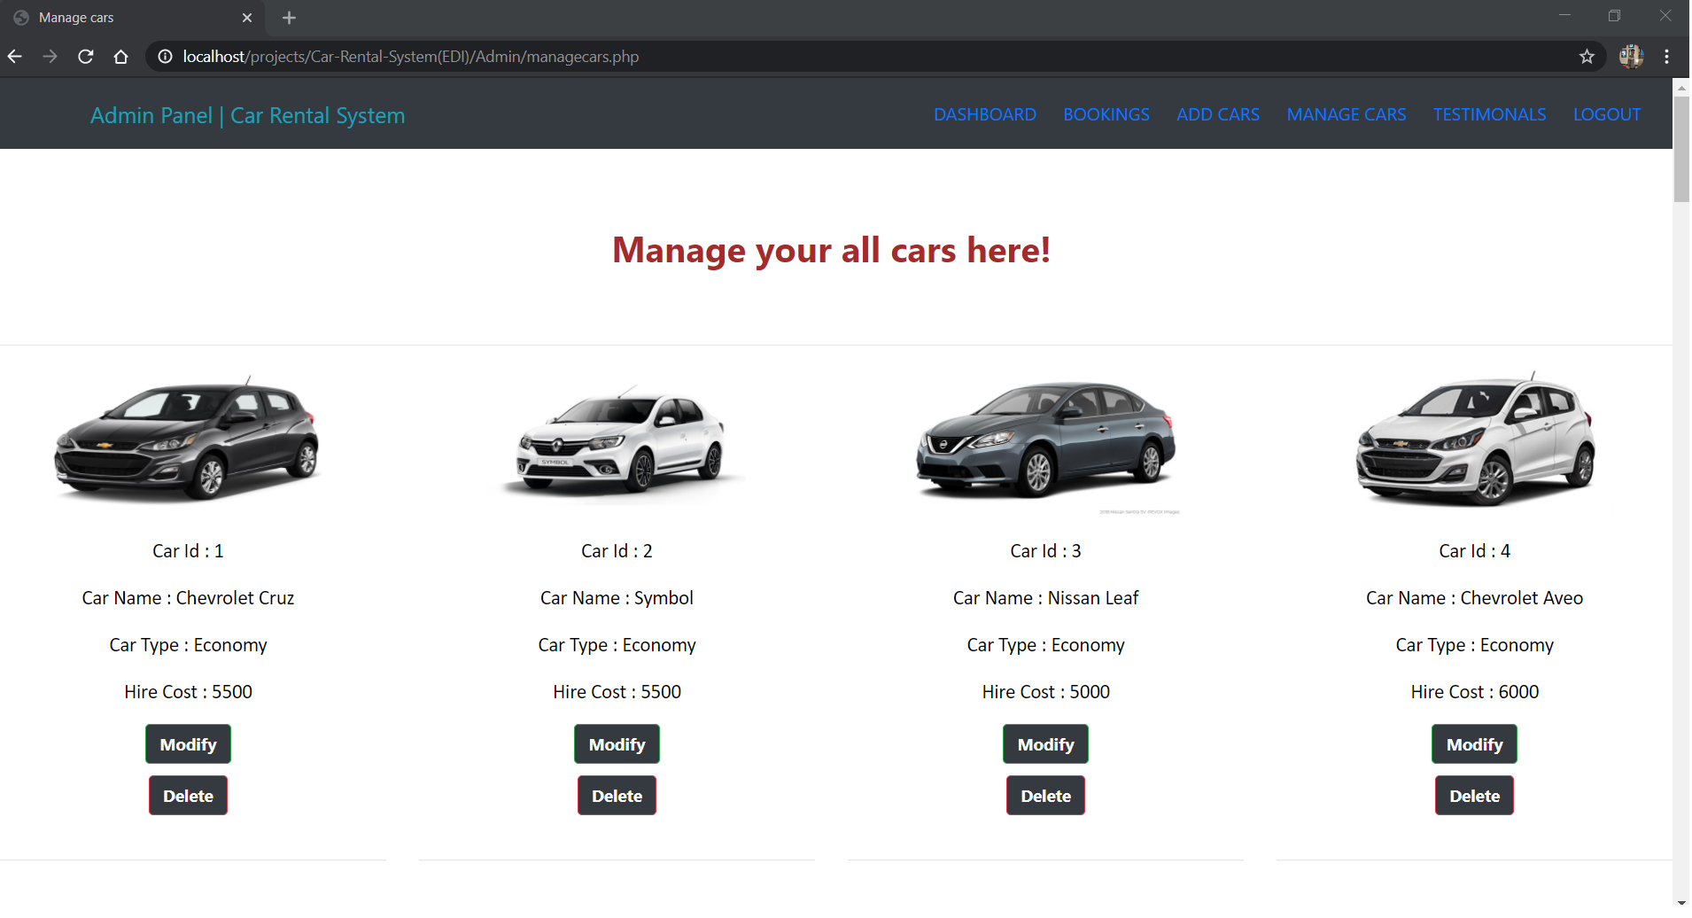

# **Requirements found from Prototyping:**

As to increase user interaction with our system and also to get intuition about any other cases that we have to implement further, we took a review-survey of the system from our users. So below are the points that are mentioned by them.

1. **To provide a flexible Refund Policy & print invoice option.**
2. **To Integrate multiple payment options in Payment Gateway**
3. **To provide rental statistic report**